1. 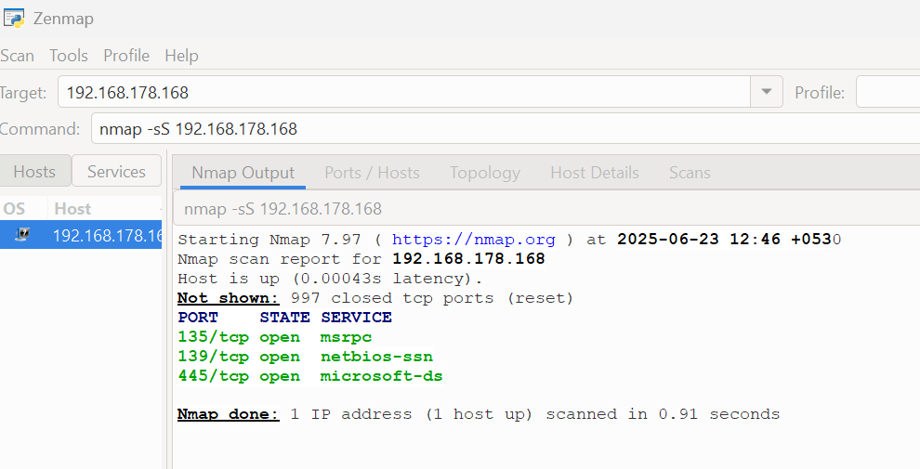**IP Address and open ports found in NMAP**
2. **COMMON SERVICES RUNNING ON PORTS**

135 port

139 port

445 port

1. **Security risks from open ports**

Ports Risk factors

135 Unauthorized Access and Remote Code Execution (RCE)

139 Ransomware, worms, remote access trojans, and man-in-the-middle attacks.

445 susceptibility to various attacks like ransomware and malware infections